Name: _Todd Carter______ Major: __Computer Science___
CAPSTONE PROJECT BID PORTFOLIO
Due at Beginning of Class on Thursday, September 4
PART 1:
Insert a small picture of yourself.
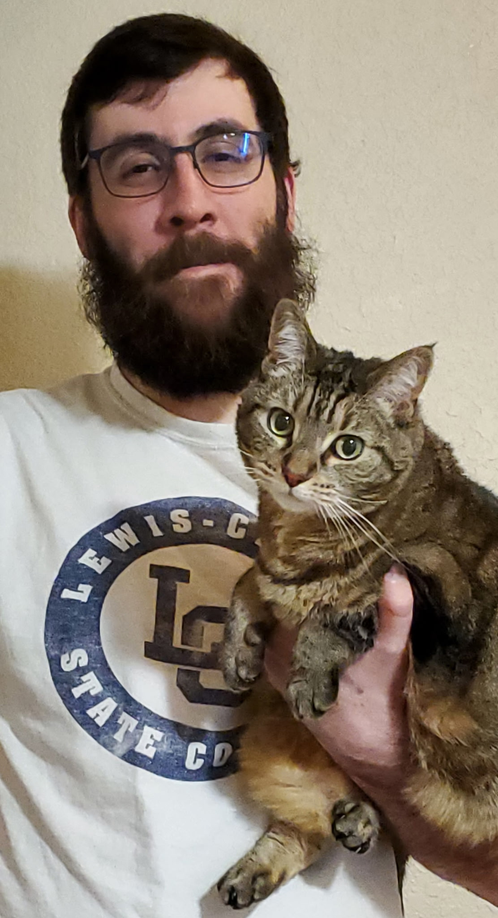

PART 2:
List your Top 5 project choices (by number & name) in Rank Order.

 | Project # | Project Name
First choice: | 29 | VR Cleanroom
Second choice: | 47 | Modbus ICS Protocol Support for Unreal Engine 5 Plugin
Third choice: | 22 | NASA Advanced & Intelligent Small Satellite Development
Fourth choice: | 54 | AI for Agriculture
Fifth choice: | 45 | AI-Powered Academic Planner Agent 1

Describe your career goals after graduation. Are there specific industries or fields you want to work or study? Do you want to pursue a job in industry or academia?

After graduation, my goal is to find a stable job with regular hours that offers good work/life balance. Ideally, I would find remote work that affords me the ability to care for my family. I have work experience with both aeronautic and with agricultural technologies and would be glad to be working in either industry again, particularly being able to build simulations. My dream would be working developing video games, which has always been my great personal interest even if life pushed me a different direction.

My GPA now does not reflect my capabilities, as I am a long-returning student who once tried (and failed) to get through a Biology degree due to external pressures. At the time of my first academic attempt, I did not know about the “withdraw from class” system, and as a result, I have old, black marks that I am attempting to have turned to Withdrawal credits now. My recent grades, especially those in Computer Science, represent my real interest and dedication.

Provide a one paragraph rationale for each choice, addressing the following questions.
- How is this choice related to your professional interests/career goal?
- What new insights, beyond the online description, were gained about this project and the sponsor/client through interactions at the Project Fair?
- What technical skills are needed in this project and how will you acquire/provide these?

29 VR Cleanroom
This option provides me the chance to work with Unity and other tools such as Blender to produce a virtual environment. Over the summer, I practiced producing 3D and 2D models which could be put to use in making simulations and gamemaking, and I have further experience with Unity. Working at the Boeing 737 Renton Facility, I experienced virtual tour guide systems that were designed to improve workplace safety. From the Project Fair, it was interesting to learn that this project has been undertaken in the past. Also interesting was that this was to be built using generic reference materials online, which made me wonder if it would be possible to tour a real clean room.

47 Modbus ICS Protocol Support for Unreal Engine 5 Plugin
This project would give me incentive to further work on and understand the Unreal Engine 5 platform, as well as working with my original skillset as an electronics technician. Building Digital Twins in order to simulate real world applications is again a significant reason why I am here in school. This project would have me learning Modbus as well as expanding on what I know of Unreal Engine.

22 NASA Advanced & Intelligent Small Satellite Development
This option provides me further access into the aviation industry, specifically advanced aeronautics. Having worked in the aeronautics industry before, this would provide me with new opportunities and directions to go. My experience previous experience is as an electronics technician, so I may have applicable skills already even if this project is lighter on computer science.

54 AI for Agriculture
Previously, I worked for Addium, a company owned by METER Group, which produces scientific agricultural equipment as an electronics technician. Addium and METER Group use huge amounts of soils data to produce their models for their tools, and they had expressed to me at the time their interest in using AI to help process information. During the Project Fair, we learned more about what data would be collected and how it would be used by the end of the project.

45 AI-powered Academic Planner Agent 1
With the changing world around us, building AI tools is becoming a crucial skill for software development. This project would allow me the chance to see the construction of an AI tool from the ground up using a relatively controlled and well-understood process. Getting and building new skills around AI is a major goal for being here in school and I am eager to learn how AI can be used in a professional setting.

PART 3:
Many of our externally funded projects require a Student Educational Activity (SEA) agreement between the university and the sponsor. This agreement ensures that the funding sponsor will be entitled to retain the intellectual property developed via the project. Without this agreement, sponsors would be reluctant to provide opportunities for us to work on projects that affect their business. As a result, if you request a project requiring an SEA, and you are assigned to a team on an SEA project, you will be asked to sign a Student Activity Participation Agreement (SAPA). Please indicate your willingness to sign an SAPA agreement if you are assigned to one of these projects.
_____ I am willing to sign a SAPA agreement if I am assigned to an SEA project.

PART 4: Personnel Survey
Complete the following personal material, which will help us to know you better and to make an appropriate capstone design assignment for you. Please respond honestly, thoroughly, and thoughtfully. Provide support for each of your answers.

Your Name: ___________________________ Hometown: ____________________

Dept./Program: _______ GPA: __________ Graduation Date: _________________

- What is your anticipated level of commitment to the project? Do you desire a role as leader or project manager? Or do you prefer to add value as a solid team member?

I am anticipating a high level of commitment, as I have room in my schedule to dedicate myself to the project. Though I generally prefer to be a team member who clearly understands what they need to do every day, I will lead a group that lacks drive and motivation.

- Identify which of the following areas you are most excited to do in contributing to your project (indicate all that apply):
- Project leadership
- Solid modeling
- Prototype build and Manufacturing
- Documentation
- Engineering Analysis

I am most interested in providing modeling, prototyping, and documentation. I would otherwise seek to lead by example through working hard and putting in the time and effort to making a strong finished product.

- List your preferences for who you might like as teammates for your project (not guaranteed).

Alex Senst and Shan Peck, if possible.
- List anyone in this class with whom you feel there is no possible way that you could work with on an extended project.

No negative preferences.

- Do you have any other commitments this year which will constrain your available time to engage on the project? Provide times which you know you will NOT be available.

Available any time other than during Theory of Computation and Machine Learning for Python.

